Final Project Design Phase
Computer Science - Week 11
Oct 3, 2026 - Version 0.0.4

For complete instructions and project ideas, refer to the assignment in Canvas. Specifically, review the final project requirements before you continue below. If you have not reviewed the project requirements in Canvas (you might have to go to the modules view and check the current or past week's content), you will not be able to properly complete the parts below. In addition, it may be helpful to review the information on this Drafter documentation page.

0) Project Planning and Preparation
Successful programmers spend time planning before they begin coding. After reviewing the project requirements, answer the following questions to help guide your design and development process.
- What concepts from class or previous assignments might help you complete this project? Which programming concepts (loops, conditionals, lists, classes, etc.) do you expect to use? What programming skills do you want to improve while completing this project?
I expect to use dataclasses for storing information about individual stocks, lists to keep track of the multiple investments, loops to calculate the total value of the portfolio, and conditional statements to determine whether investments have gained or lost value. I will also have to use Drafter to create the different pages of the website and make it so they can interact with it. I want to improve my ability to organize large programs and use multiple functions to create something that works well.

- Which parts of the project do you expect to be the easiest for you? The hardest? Why?
The easiest part will simply be the calculations for the portfolio values as basic mathematical operations are easy in python. Creating dataclasses to store stock information shouldn’t be that hard either. The hardest part will be connecting multiple pages using Drafter routes and making sure info entered by the user is stored and updated properly

- Even though you have not yet designed the final project, estimate which tasks will likely require the most time and effort? Which features or components should be implemented first?
The longest tasks will be creating the different pages, especially the ones that users can interact with heavily. I think i should begin with the dataclasses as the whole website will depend on them, then I can design functions that will do the calculations and go from there.

- What distractions might interfere with your work and how will you minimize them? What resources will you need available while working? What questions, if any, do you still have about the assignment requirements?
Other classes, studying, and my phone will take away from time on this project. I like to work outside my dorm with my phone in my bag to minimize this. I don’t have any questions.

1) Site Diagram
Create a mock-up of your planned website. We suggest you make the mockup on paper, although you can also use software like PowerPoint or Slides to make a mockup. There is other design software that could also be used, but we strongly encourage you to keep it simple. Do not spend more than 15-30 minutes detailing the mock-up. Your goal should be to make a very quick and dirty diagram, to show that you have some kind of idea.

We recommend drawing each page as a rectangle, and laying out the text, buttons, and other components inside. Then, use arrows to indicate links between pages. Label each page the way you will name each function, and then put labels on the arrows to indicate what the button links. Also write down any parameters that should come into the pages.

In addition to the pages and routes, write down what fields your `State` will have, both their names and types. Think clearly about what data will need to be persistent across the entire website.

Add photo(s) or screenshot(s) of your website mock-up and labeled diagram on the next page.

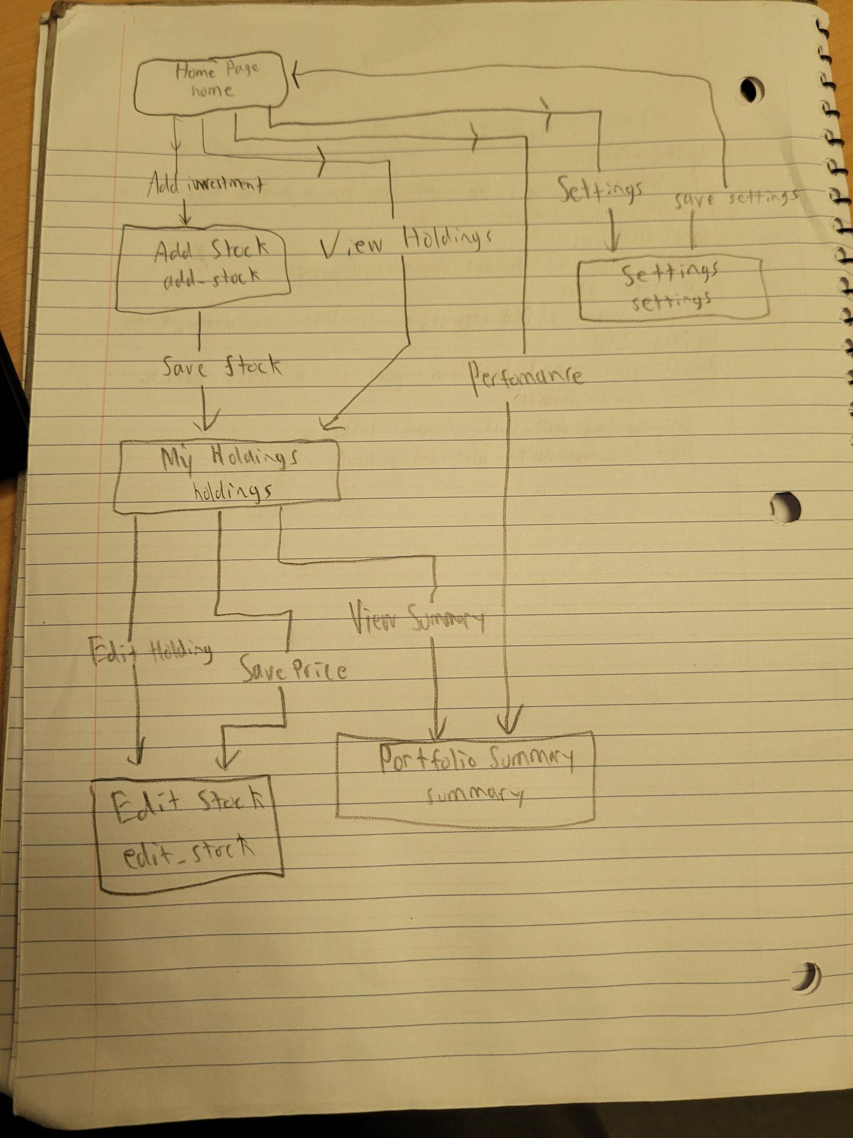
2) Implementing Requirements
This table should serve as a draft for how you will implement the requirements into your final project. You may change your ideas later on, but your final site must fulfill all the requirements.

Requirement | Implementation
Purpose/Functionality  A 1-2 sentence description of the purpose or functionality of your site | My website will be a stock portfolio tracker that allows users to record their investments and monitor their performance. Users will be able to add or remove stocks, update their prices, and view their total portfolio value and investment returns.
State Dataclass Attributes  Minimum of 4 attributes, one of which must be a list/dict of instances of your second dataclass.  Briefly describe each attribute, its type, and how it will be meaningfully modified throughout the site. | My State dataclass will contain stocks:list[Stock],portfolio_name: str, investment_goal: float, and cash_balance: float.  The stock list changes when users add or remove investments, the other three attributes can be updated through the settings page, allowing users to rename their portfolio, change their investment goals, and add cash.
Second Dataclass  Your second dataclass, including its attributes, their types, and how they will be meaningfully modified (if they are modified) | I will create a Stock dataclass containing, symbol: str, shares: float, purchase_price: float, and current_price: float. Each instance represents an investment. The current price can be updated by users to reflect the changes in the stock’s value.
Routes (minimum 7)  The names of your route functions | home, add_stock, save_stock, holdings, edit_stock, save_price, remove_stock, summary, settings, save_settings
Pages (minimum 5)  A brief description of the pages in your site | There will be six pages: Home(main menu), Add Stock(allows them to add stocks), My Holdings(shows their current stocks), Edit Stock(lets them update info), Portfolio Summary(shows how their investments have moved), and Settings(allows them to customize.
User Input (minimum 3)  Description of user input components (TextBox, TextArea, CheckBox, or SelectBox) and their purposes  For more information on these input types, see Drafter Documentation. | I will use TextBoxes for stock symbols, shares owned, purchase prices, and current prices, portfolio name, investment goal, cash deposit.
If Statements (minimum 3)  Brief description of what will be evaluated in your if statements and how they will meaningfully change the logic of the site | The first will be to determine whether a stock has gained or lost value, the second will check whether users entered valid share quantities and prices, the third will check whether the portfolio contains any stocks before calculating. I may use a fourth to check whether the user’s portfolio has reached the investment goal.
Loop (minimum 1)  This loop must iterate over the list/dict of dataclass instances in your State attribute.  Description of this loop and why it is meaningful to the site | I will use a for loop to iterate through the stocks list in State, the loop will calculate each stock’s value and determine the total portfolio value. It will also be used to display all investments on the Holdings page.

LLM Conversation
If you used an LLM in any part of this work, copy and paste every part of that conversation below. Otherwise, you may be given a zero for the assignment. Obviously, these words will not all be yours, and this is the exception to the requirement at the top of this assignment that all responses be in your own words. If you did not use an LLM to assist you in this assignment, simply say so below.
I did not use an llm for this assignment

Final Submission
When you are finished, download this file as a Word Document (docx) and upload the file to the appropriate assignment on Canvas.

